 

**Lebanese Canadian University – LCU**

Faculty of Arts and Science – FSA

Bachelor in Computer Science

Final project

**Hoptify**

Presented by

**Ahmad Jarad**

**Hadi Mortada**

**Hasan Kazzaz**

**Jimmy Mansour**

**Charbel Chaine**

Supervised by

**Dr. Georgio KHALIL**

Jun, 15 2022

Table of Contents

1 Introduction 3

1.1 Overview 3

1.2 Scope 3

1.3 Goals and Objectives 3

1.4 Business Statements 3

1.5 Acronyms and Abbreviations 3

1.6 Points of Contact 4

2 General Design Constraints 5

2.1 Mandated Constraints 5

2.2 Potential System Evolution 5

3 Nonfunctional Requirements 6

3.1 Performance Requirements 6

3.2 Security Requirements 6

3.3 Safety Requirements 6

3.4 Legal Requirements 6

3.5 Documentation and Training 6

4 System Architecture 7

4.1 Software Interface 7

Technical Specifications 8

4.2 Admin Module 8

4.2.1 Flow Chart 8

4.2.2 Features 8

4.3 User Module 13

4.3.1 Flow Chart 13

4.3.2 Features 13

4.3.3 ERD Diagram (FOR BOTH USER AND ADMIN MODULES) 16

16

# Introduction

## Overview

Hoptify is an Android Application that has been developed to provide a new way of medical treatment. In Face, Medical treatment is one of the most important things we should take care of. Thus, we created this application a fast and stable interface that will help patient to take care of their health in time saving way and help the clinic to maintain their work in the easiest way!

## Scope

Using the application, Patient will be able to view clinic’s sections, doctors inside each section and the doctor’s appointment through the week and then book it. On of the best advantages is that the appointments have specific time which will make the idea of the application unique. In Addition, there will be Admin Side (Hoptify Managers) on which the secretary of the section can accept their section doctor’s appointments or reject them, add his weekly schedule, send him a note and accept notes from them also.

## Goals and Objectives

There are several goals of the application. Here are the main:

* Time saving for patient.
* Easy access to the application through mobile.
* Employees can maintain their work easier.
* Everyone can the application from patient side.
* Only Clinic’s Employees can access the second Application. (Hoptify Managers)

## Business Statements

* User Must Sign in before using the application
* Admin can prevent users from logging in
* User can see doctors’ Available appointments
* User can see his appointment status (pending, approved, rejected, missed, finished)
* Each appointment has specific time which can be booked.

## Acronyms and Abbreviations

Hoptify: Lebanon

Hoptify Managers: Lebanon

## Points of Contact

|  |  |  |  |  |  |
| --- | --- | --- | --- | --- | --- |
| Contact Name | Contact Type | Department | Telephone Number | Email | Oversight Function |
| Ahmad jarad | Owner | IT department | 71896312 | Ahmadjrad2019@gmail.com | Developer |
| Hadi Mortada | Owner | IT department | 76061631 | Hadimortada9@gmail.com | Developer |
| Hasan kazzaz |  | IT department | 76012800 | Hkazzaz100@gmail.com | Developer |
| Jimmy mansour | Owner | IT department | 76456278 | Jimmy.mansour96@gmail.com | Developer |
| Charbel chahine | Owner | IT department | 71421394 | Chaine.1@outlook.com | Developer |

# General Design Constraints

## Mandated Constraints

The application has the following constraints:

The Application Language is only English and the application must be able to adapt all phone’s screen sizes. In addition, the application has ease of access to any android device with internet connection but he must sign in to be able to use the application

## Potential System Evolution

For the Future, we can add more languages to the application so more users will be able to use it fluently. Also, we can work on a chat system between secretaries and patient which will provide more support to the application. We can add forget password function for users who forget their password. However, we can convert the application to be globally used not only in Lebanon and add online payments. In Addition, adding registration using mobile Number (OTP)

# Nonfunctional Requirements

## Performance Requirements

The application is developed in a smooth way, so the wait time for the application to load is about 10 seconds (including splash screen animations) and then the time to move from activity to another is supposed to be about 5 seconds with a stable internet connection provided.

## Security Requirements

The Database will not be able to accessed by anyone as it remains private on a cloud storage.

## Safety Requirements

The user’s credentials (password) are totally secured using md5 Encryption which will prevent the leak of passwords. And each user’s data is private and will remain secure and not hackable.

## Legal Requirements

User data will not be shown to other users.

Data are private to the other users of this application.

## Documentation and Training

The Application is built to be easy to use, thus it doesn’t require a tutorial or documentation for the user to use it.

# System Architecture

## Software Interface

The application is developed using android studio (java) and the database are stored in MySQL database.

# Technical Specifications

## Admin Module

The Admin Module is managed through separate application (Hoptify Managers) in which admin can control the users accounts (Deactivate – Activate) including clinic’s employees. Also, clinic’s employees can sign in in the admin module and maintain their work inside of it

### Flow Chart

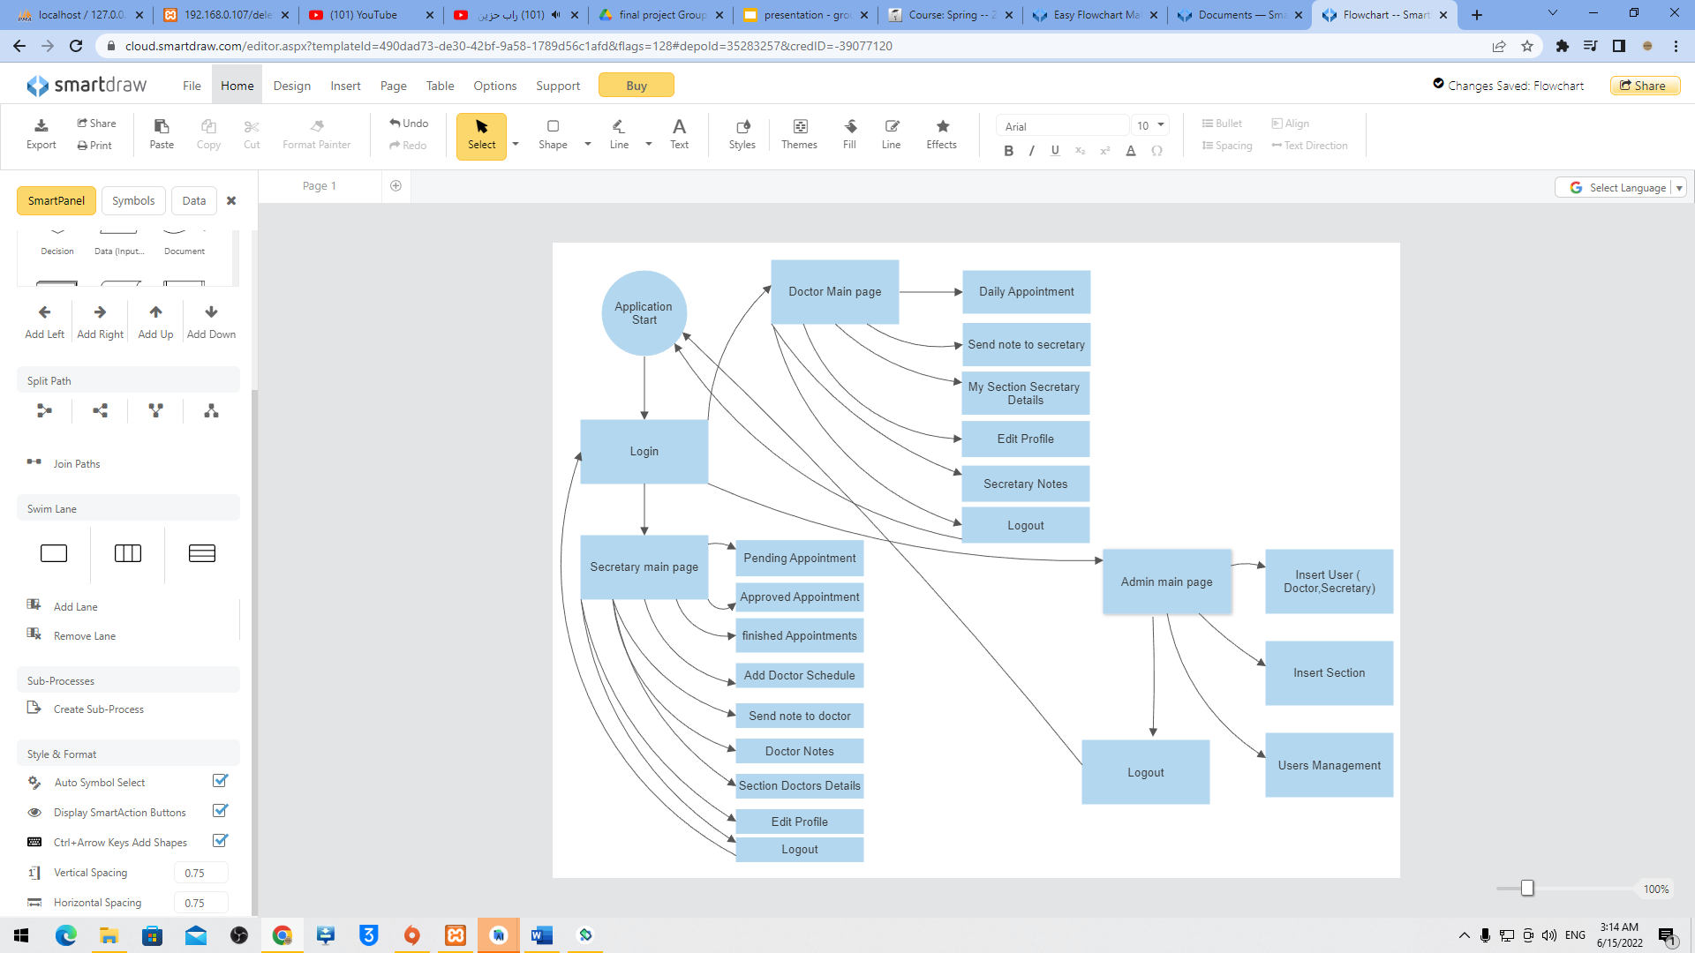

### Features

Doctor can see his section secretary details

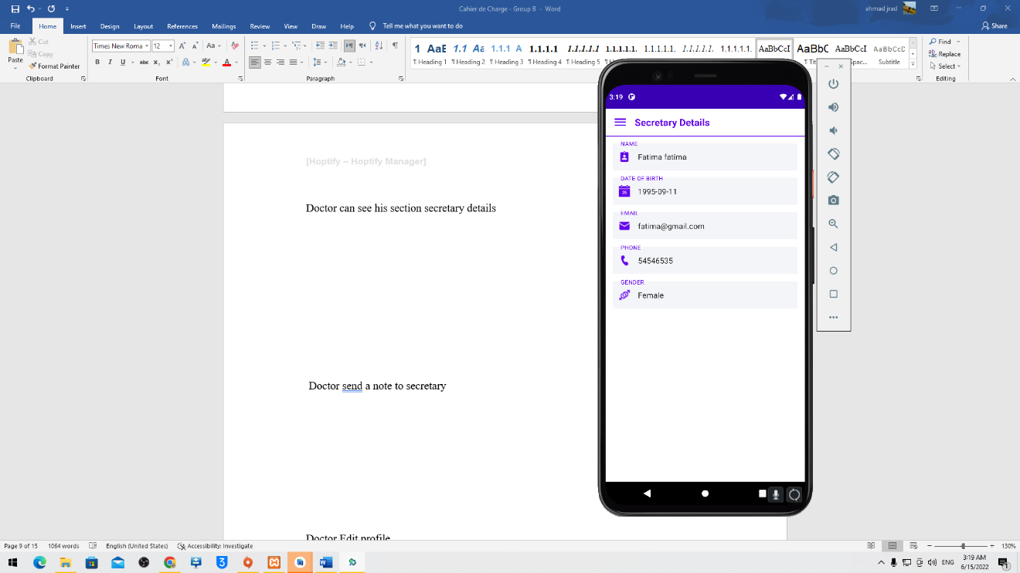

Doctor sends a note to secretary

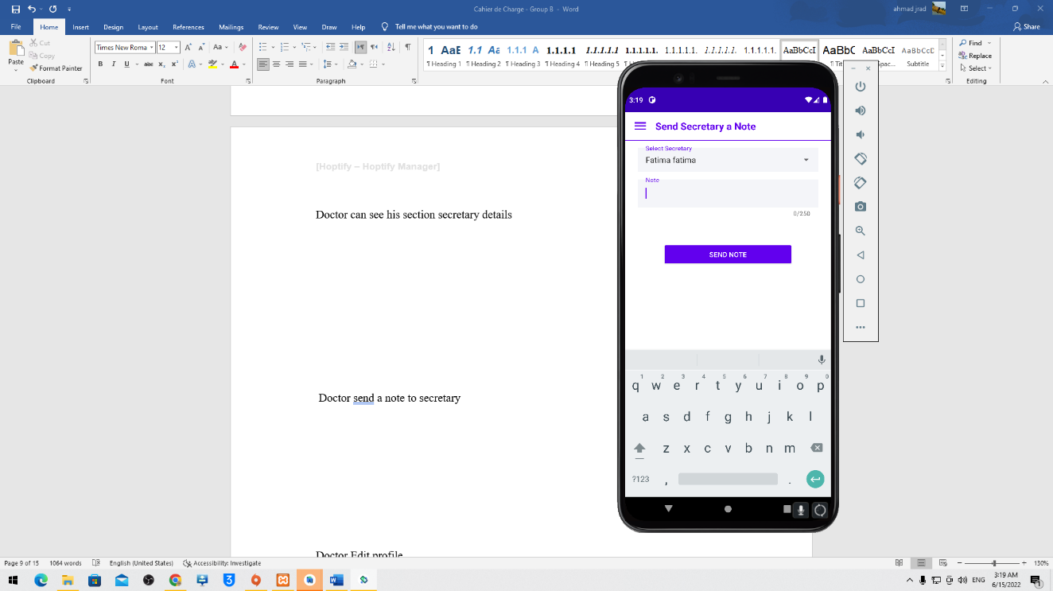

Doctor Edit profile

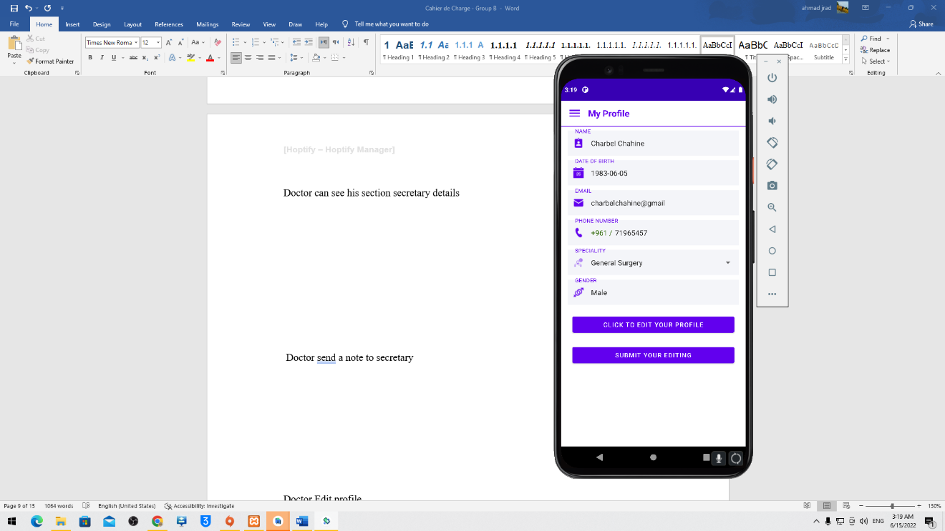

Doctor view daily appointments

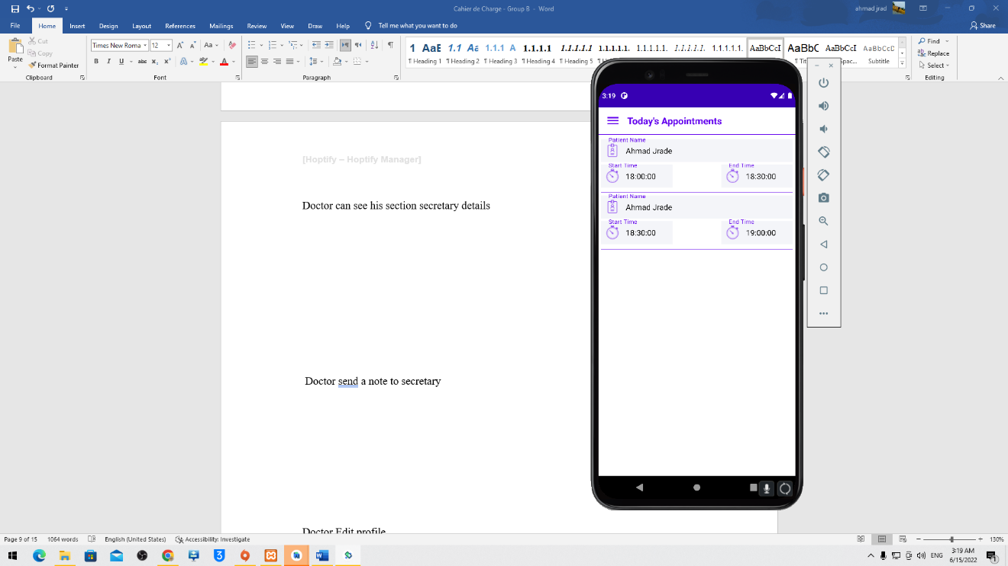

secretary can see her section doctors

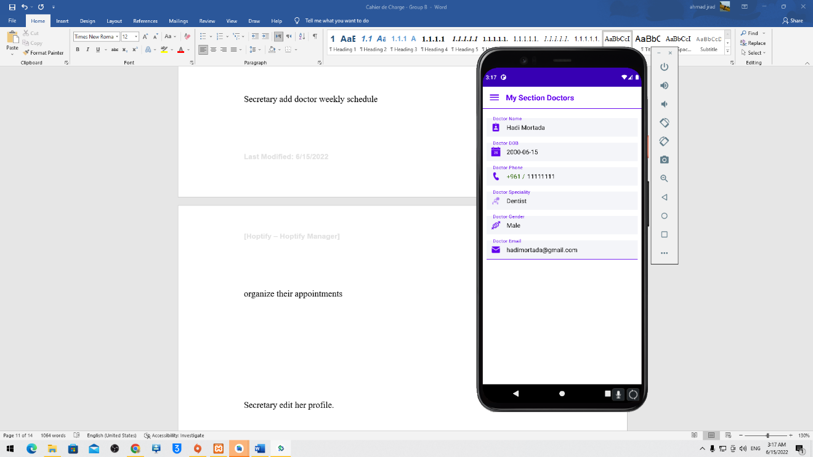

Secretary add doctor weekly schedule

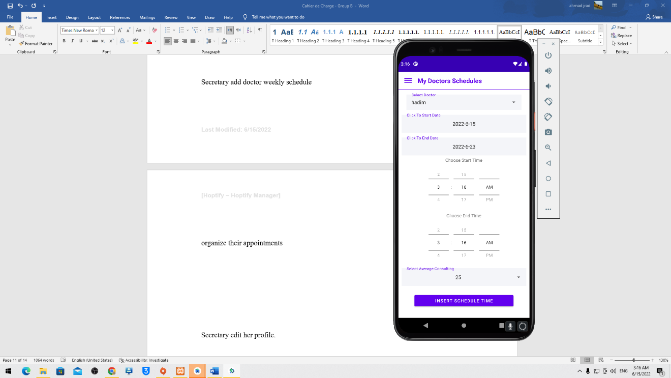

organize their appointments

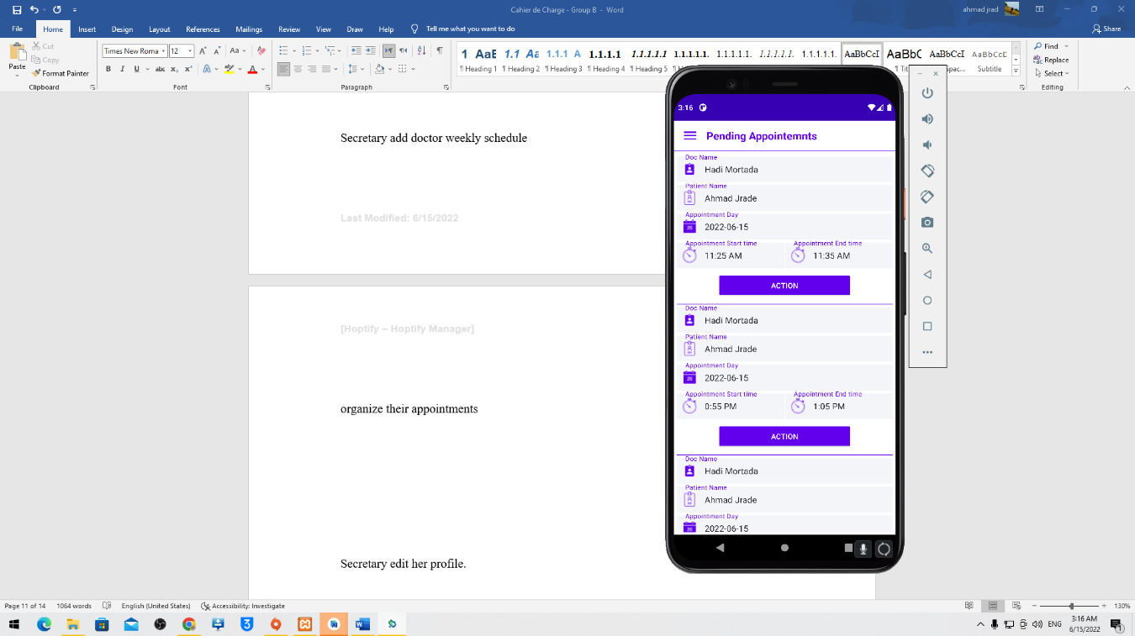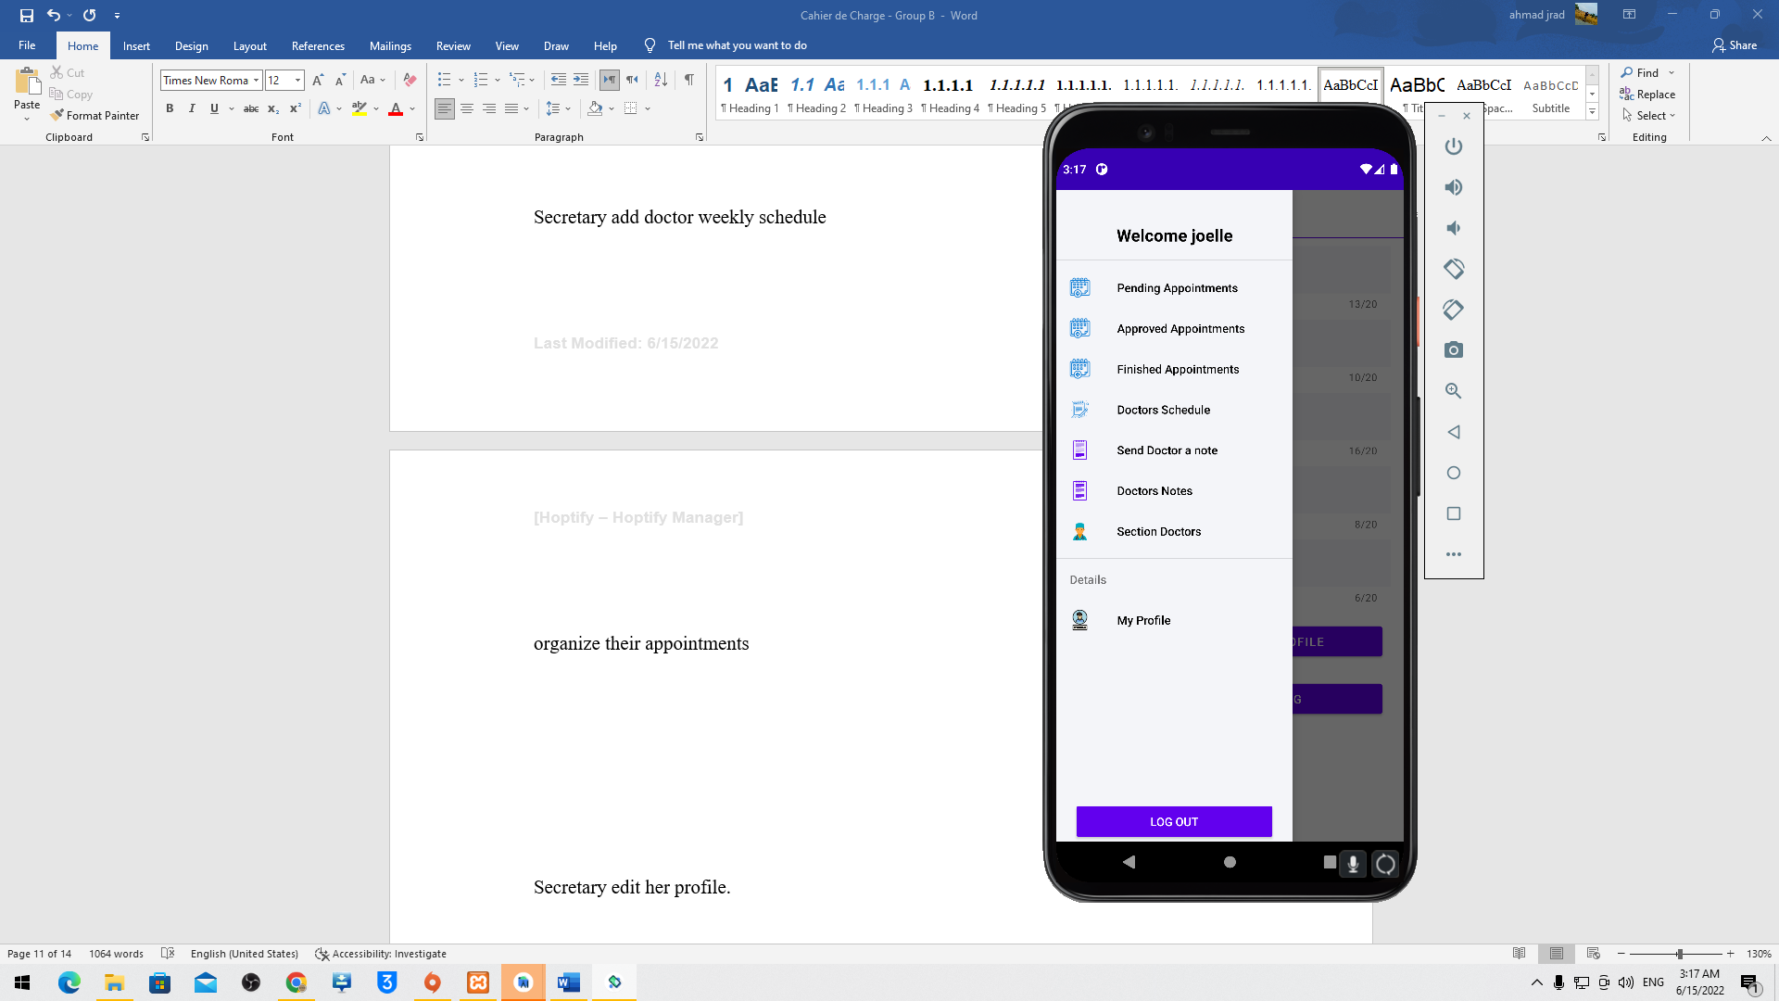

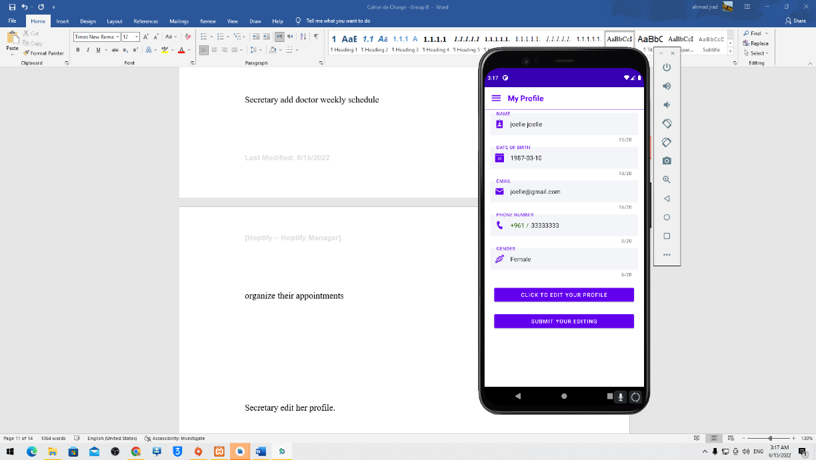Secretary edit her profile.

## User Module

### Flow Chart

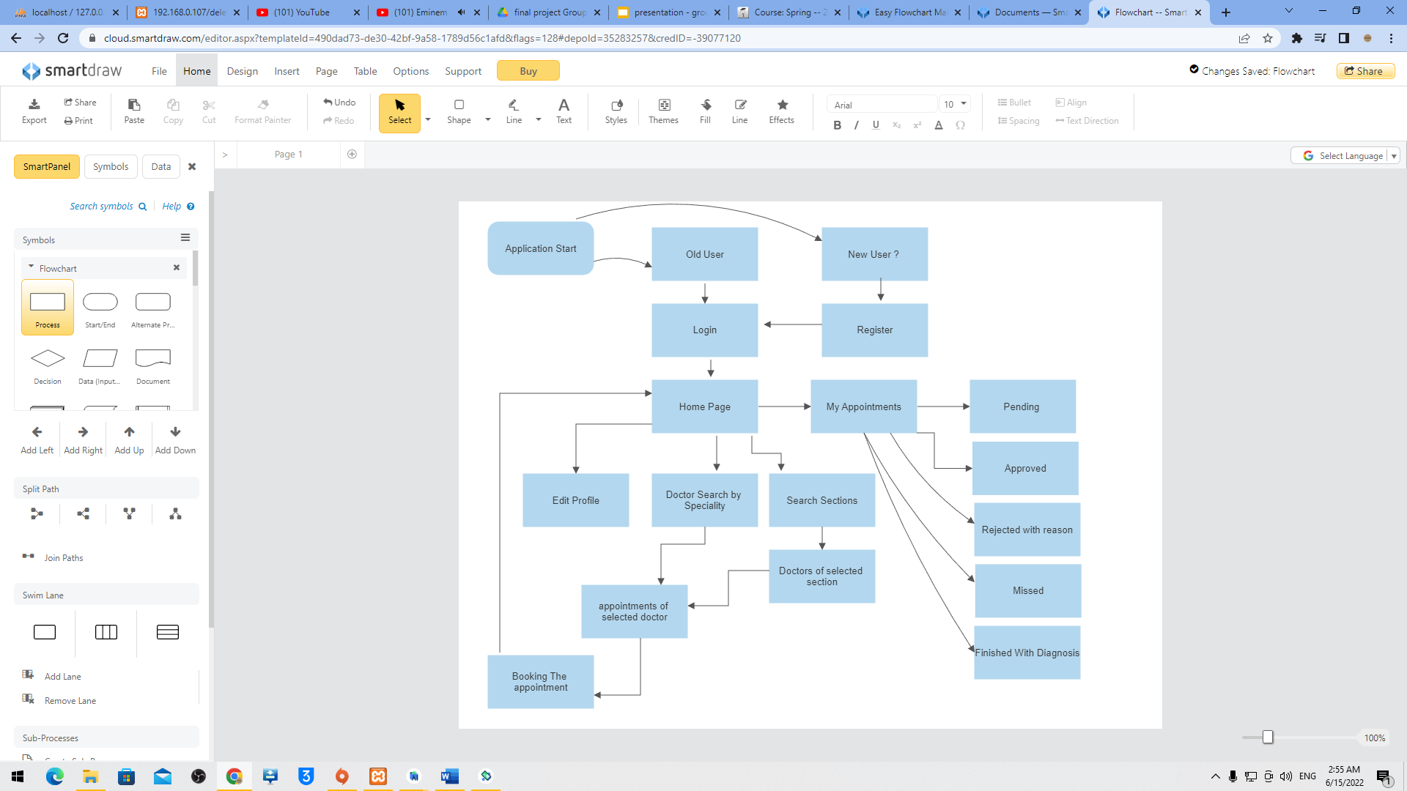

### Features

User must create an account before he uses the application.

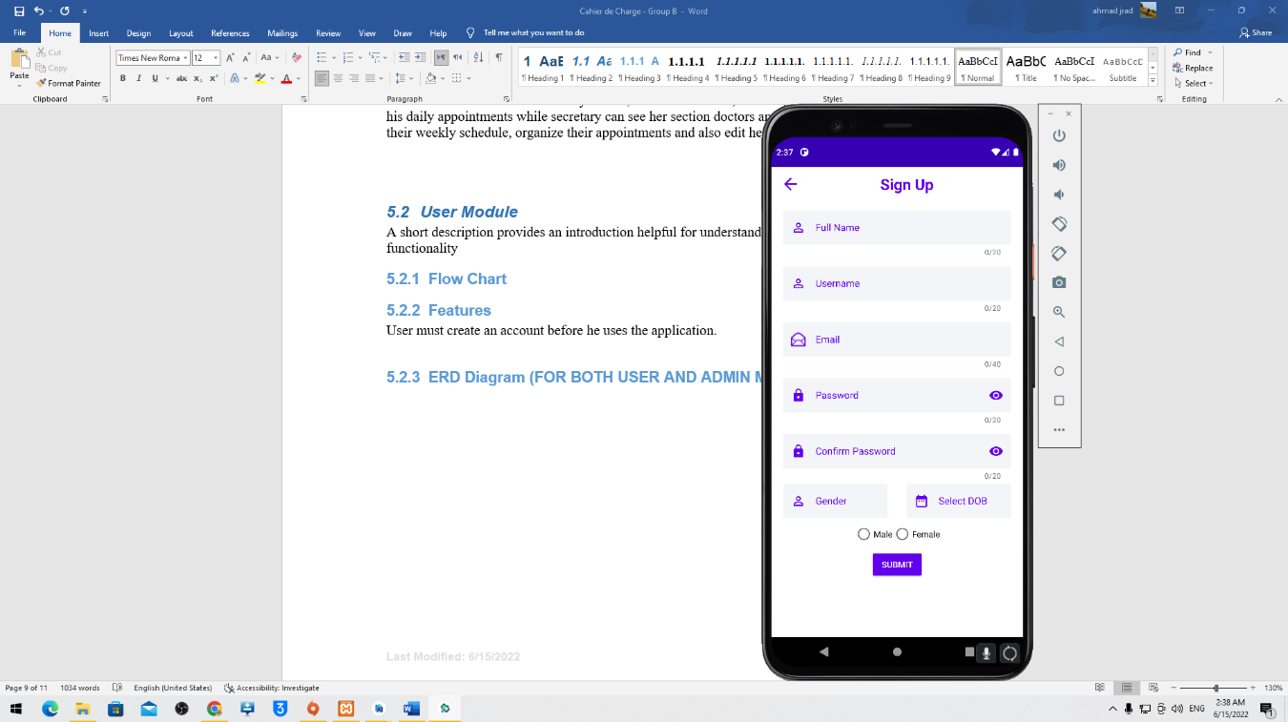

The User can see doctors of each specialty or doctors of each section

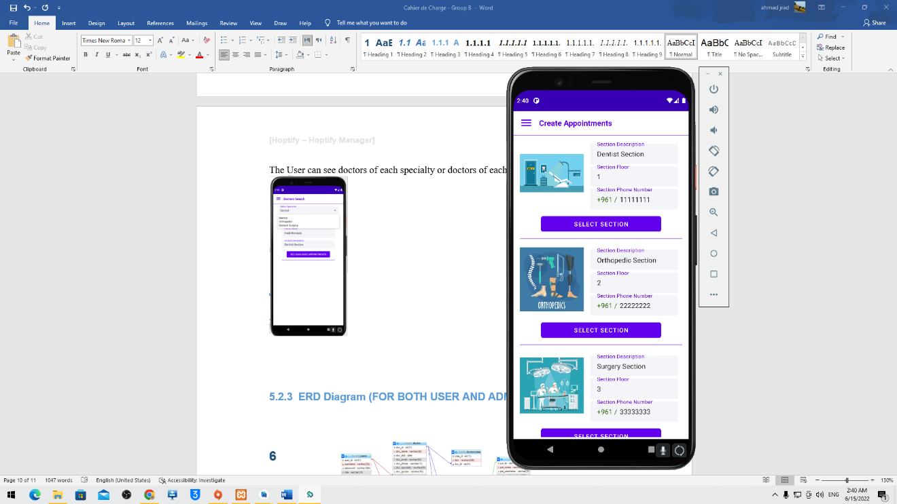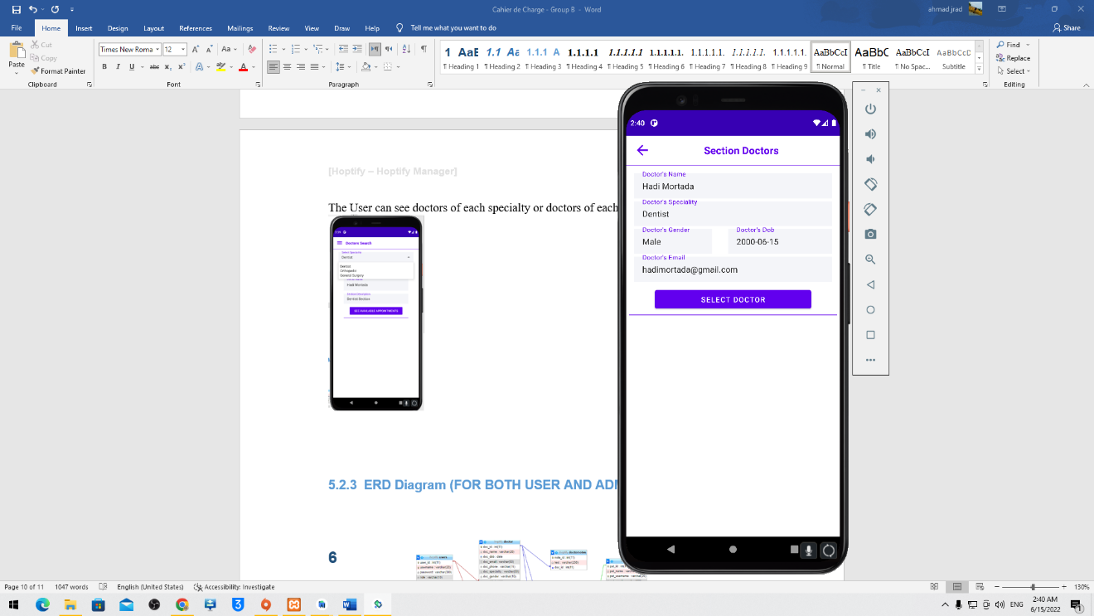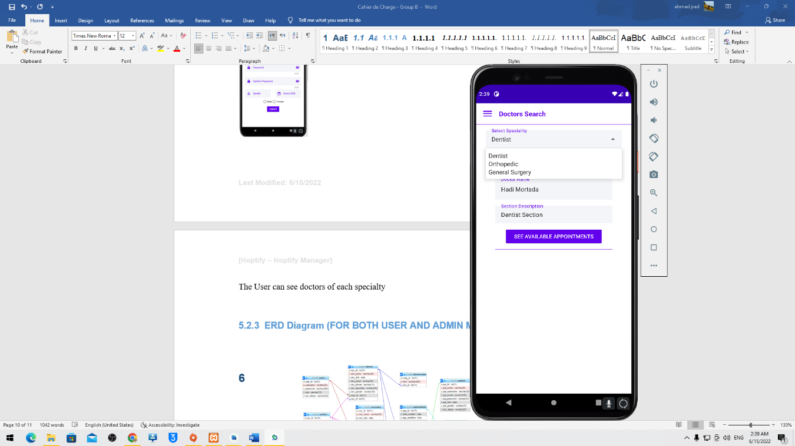

The user can see the doctor’s appointment and book them

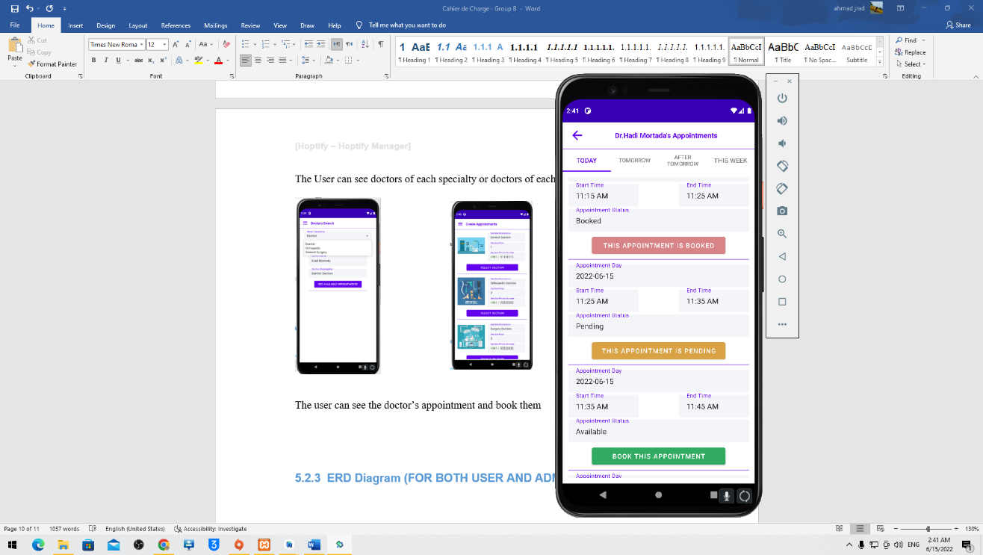

The user can see his appointments status (Pending, Approved, Rejected, Missed, Finished) and diagnosis of finished ones.

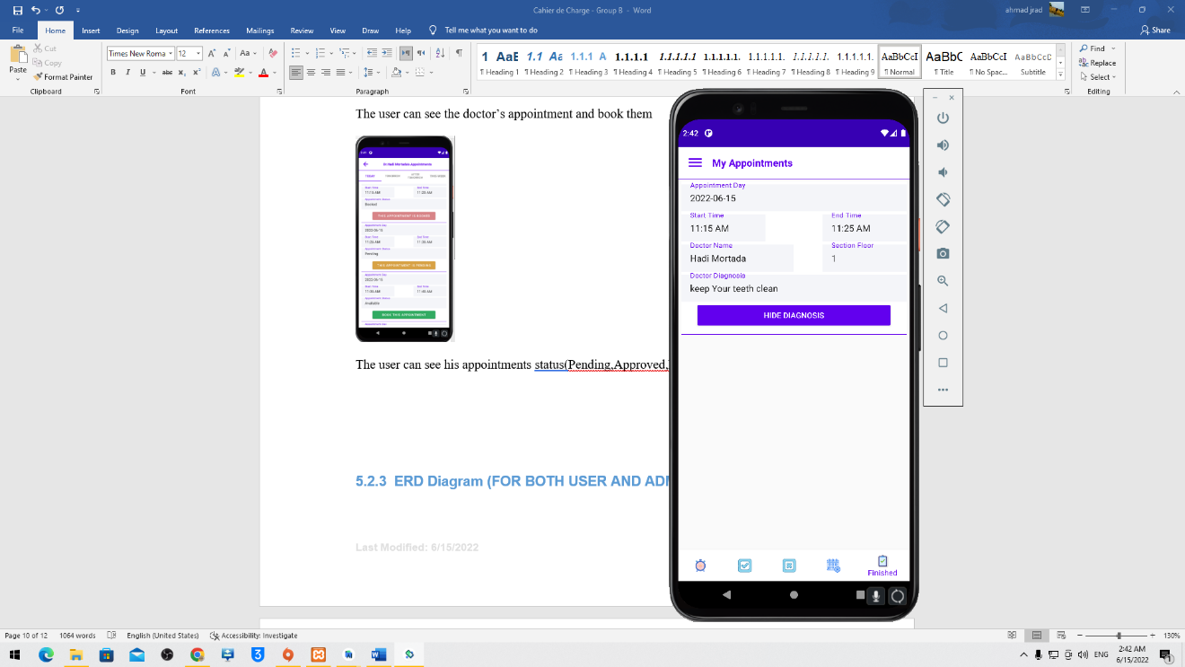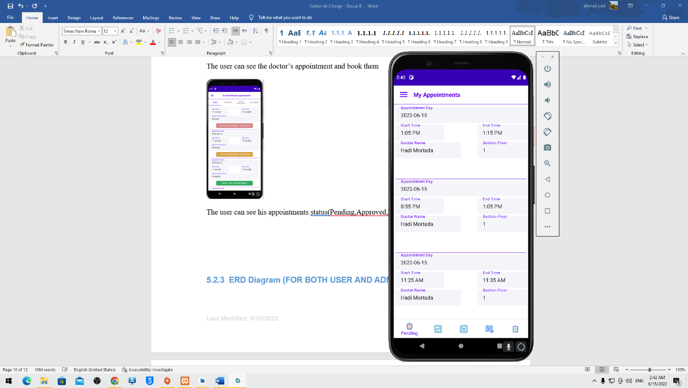

Last, the user can edit his profile

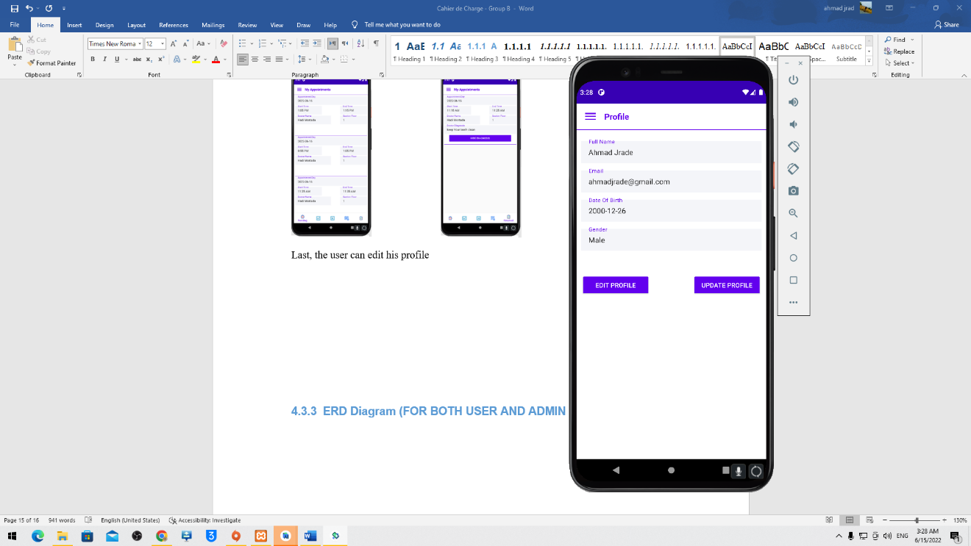

### ERD Diagram (FOR BOTH USER AND ADMIN MODULES)

# 